



UNIVERSITY OF CAMBRIDGE INTERNATIONAL EXAMINATIONS General Certiﬁcate of Education   
Advanced Subsidiary Level and Advanced Level

**MATHEMATICS**  **9709/01**

Paper 1 Pure Mathematics 1 **(P1)**   
 May/June 2005

**1 hour 45 minutes**

Additional materials: Answer Booklet/Paper   
 Graph paper   
 List of Formulae (MF9)

**READ THESE INSTRUCTIONS FIRST**

If you have been given an Answer Booklet, follow the instructions on the front cover of the Booklet. Write your Centre number, candidate number and name on all the work you hand in.   
Write in dark blue or black pen on both sides of the paper.

You may use a soft pencil for any diagrams or graphs.

Do not use staples, paper clips, highlighters, glue or correction ﬂuid.

Answer **all** the questions.

Give non-exact numerical answers correct to 3 signiﬁcant ﬁgures, or 1 decimal place in the case of angles in degrees, unless a different level of accuracy is speciﬁed in the question.

At the end of the examination, fasten all your work securely together.

The number of marks is given in brackets [ ] at the end of each question or part question.

The total number of marks for this paper is 75.

Questions carrying smaller numbers of marks are printed earlier in the paper, and questions carrying larger numbers of marks later in the paper.

The use of an electronic calculator is expected, where appropriate.

You are reminded of the need for clear presentation in your answers.

This document consists of **4** printed pages.

© UCLES 2005 **[Turn over**





**2**

|  |  |  |  |
| --- | --- | --- | --- |
| **1**  **2**  **3**  **4** | A curve is such that d*y* the curve. d*x*= 2*x*2 − 5. Given that the point (3, 8) lies on the curve, ﬁnd the equation of [4] | | |
| Find the gradient of the curve *y* = | *x*2− 4*x*at the point where *x* = 3. | [4] |
| **(i)** Show that the equation sin θ + cos θ = 2(sin θ − cos θ) can be expressed as tan θ = 3. **(ii)** Hence solve the equation sin θ + cos θ = 2(sin θ − cos θ), for 0◦≤ θ ≤ 360◦. | | [2] [2] |
| **(i)** Find the ﬁrst 3 terms in the expansion of (2 − *x*)6in ascending powers of *x*.  **(ii)** Find the value of *k* for which there is no term in *x*2in the expansion of (1 + *kx*)(2 − *x*)6. | | [3] [2] |

**5**



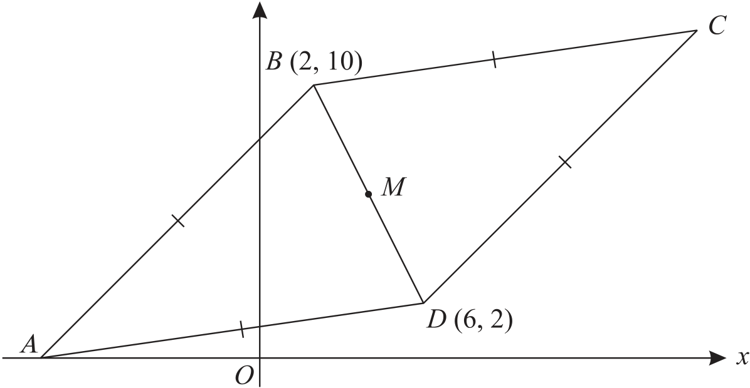

The diagram shows a rhombus *ABCD*. The points *B* and *D* have coordinates (2, 10) and (6, 2) respectively, and *A* lies on the *x*-axis. The mid-point of *BD* is *M*. Find, by calculation, the coordinates of each of *M*, *A* and *C*. [6]

**6**  A geometric progression has 6 terms. The ﬁrst term is 192 and the common ratio is 1.5. An arithmetic progression has 21 terms and common difference 1.5. Given that the sum of all the terms in the geometric progression is equal to the sum of all the terms in the arithmetic progression, ﬁnd the ﬁrst term and the last term of the arithmetic progression. [6]

© UCLES 2005 9709/01/M/J/05



**3**

|  |  |  |
| --- | --- | --- |
| **7** | A function f is deﬁned by f : *x* �→ 3 − 2 sin *x*, for 0◦≤ *x* ≤ 360◦. | [2] |
| **(i)** Find the range of f. |
| **(ii)** Sketch the graph of *y* = f(*x*).  A function g is deﬁned by g : *x* �→ 3 − 2 sin *x*, for 0◦≤ *x* ≤ *A*◦, where *A* is a constant. | [2] |
| **(iii)** State the largest value of *A* for which g has an inverse. | [1] |
| **(iv)** When *A* has this value, obtain an expression, in terms of *x*, for g−1(*x*). | [2] |

**8**

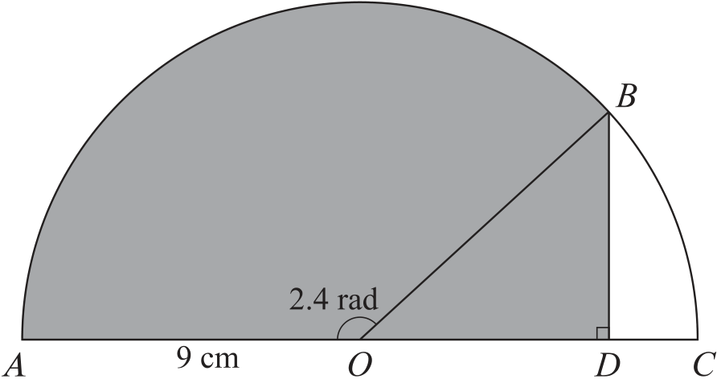

In the diagram, *ABC* is a semicircle, centre *O* and radius 9 cm. The line *BD* is perpendicular to the

diameter *AC* and angle *AOB* = 2.4 radians.

**(i)** Show that *BD* = 6.08 cm, correct to 3 signiﬁcant ﬁgures. [2]

**(ii)** Find the perimeter of the shaded region. [3]

**(iii)** Find the area of the shaded region. [3]

**9**  A curve has equation *y* =4√*x*.

**(i)** The normal to the curve at the point (4, 2) meets the *x*-axis at *P* and the *y*-axis at *Q*. Find the length of *PQ*, correct to 3 signiﬁcant ﬁgures. [6]

**(ii)** Find the area of the region enclosed by the curve, the *x*-axis and the lines *x* = 1 and *x* = 4. [4]

© UCLES 2005 9709/01/M/J/05 **[Turn over**

**4**

|  |  |  |  |  |
| --- | --- | --- | --- | --- |
| **10**  **11** | The equation of a curve is *y* = *x*2− 3*x* + 4. | | | |
| **(i)** Show that the whole of the curve lies above the *x*-axis. | | | [3] |
| **(ii)** Find the set of values of *x* for which *x*2− 3*x* + 4 is a decreasing function of *x*. [1]  The equation of a line is *y* + 2*x* = *k*, where *k* is a constant.  **(iii)** In the case where *k* = 6, ﬁnd the coordinates of the points of intersection of the line and the curve. [3] | | | |
| **(iv)** Find the value of *k* for which the line is a tangent to the curve. | | | [3] |
| Relative to an origin *O*, the position vectors of the points *A* and *B* are given by | | | |
| −−→*OA* = 2**i** + 3**j** − **k** | and | −−→*OB* = 4**i** − 3**j** + 2**k**. | |
| **(i)** Use a scalar product to ﬁnd angle *AOB*, correct to the nearest degree. | | | [4] |
| **(ii)** Find the unit vector in the direction of−−→*AB*. | | | [3] |
| **(iii)** The point *C* is such that−−→−−→*AC* are equal, ﬁnd the possible values of *p*. *OC* = 6**j** + *p***k**, where *p* is a constant. Given that the lengths of−−→*AB* and  [4] | | | |



Every reasonable effort has been made to trace all copyright holders where the publishers (i.e. UCLES) are aware that third-party material has been reproduced. The publishers would be pleased to hear from anyone whose rights they have unwittingly infringed.

University of Cambridge International Examinations is part of the University of Cambridge Local Examinations Syndicate (UCLES), which is itself a department of the University of Cambridge.

© UCLES 2005 9709/01/M/J/05